
TRIBHUVAN UNIVERSITY
Institute of science and technology

A Project Proposal
On
Akshar(अक्षर)

Submitted to
Department of Statistics and Computer Science
Patan Multiple Campus

In partial fulfillement of the requriments for Bachelor Degree in Computer science and Information Technology

Submitted By:
Prajjwal Lamsal (25553/077)
Koshish Pokharel (25540/077)
Anukul Banjade (25510/077)

Table of Contents
1 Introduction 5
2 Problem statement 5
3 Objectives 6
4 Methodology 6
4.1 Requirement Identification 6
4.1.1 Study of existing system 6
4.1.2 Literature Review 6
4.1.3 Data Collection 7
4.1.4 Model Development 7
4.1.5 Training and Evaluation 7
4.1.6 Deployment 7
4.1.7 Requirements Analysis 7
4.2 Feasibility Study 8
4.2.1 Technical Feasibility 8
4.2.2 Operational Feasibility 8
4.2.3 Economic Feasibility 9
4.3 High Level Design of System 9
4.3.1 Methodology of the proposed system 9
4.3.2 System Flowchart 9
4.3.3 Use Case Diagram 11
4.3.4 Description of algorithms 12
5 Gantt chart 13
6 Expected outcome 13
7 References 14

List of figures

Figure 2: Flowchart for admin 10

Figure 3: Use case diagram for users 11

Figure 4: Use case diagram for admin 12

Introduction
In an increasingly digital world, the accurate conversion of handwritten text into machine-readable formats is essential for document digitization and enhancing accessibility. The project "Akshar" aims to address the challenges of recognizing handwritten Nepali characters, written in the complex Devanagari script, by employing advanced deep learning techniques, specifically Deep Convolutional Neural Networks (CNNs). This initiative involves collecting a diverse dataset of handwritten Nepali characters and preprocessing it to ensure consistency for effective model training. By experimenting with different optimizers, namely Adam and Nadam, the project seeks to achieve high accuracy and robust performance. Furthermore, "Akshar" will feature a user-friendly web application that allows users to upload handwritten images, providing real-time feedback and audio cues to enhance engagement. Ultimately, this project aims to contribute to the digitization of the Nepali language, preserving its rich cultural heritage while making it more accessible for users and learners alike.
.

Problem statement
The recognition of handwritten Nepali characters, especially in the complex Devanagari script, is very challenging due to the different styles of handwriting and the intricate nature of the script. Current technologies for reading handwritten text often struggle with these characters, making it hard to digitize documents and limiting access for people who need digital formats. This creates a gap in tools available for less commonly digitized languages like Nepali, which affects the preservation of cultural heritage and access to educational resources. The "Akshar" project aims to develop a reliable deep learning model to accurately recognize handwritten Nepali characters, helping to improve accessibility and promote the use of the Nepali language in digital platforms.

Objectives
The main objectives of the "Akshar" project are:
- To develop a deep learning model that accurately recognizes handwritten Nepali characters in the Devanagari script.
- To compare the performance of different optimization algorithms, specifically Adam and Nadam, to determine which one provides better results for our model.
- To achieve a high level of accuracy, targeting a validation accuracy of over 90%, with the ambitious goal of reaching 99% accuracy in character recognition.
- To create a user-friendly web application that allows users to upload handwritten images and receive real-time feedback and audio cues based on the recognized characters.

Methodology

Requirement Identification
Requirement identification involves gathering the necessary information that will be used to develop the "Akshar" system. Various methods can be employed to collect these requirements, including studying existing systems, conducting interviews, and distributing questionnaires.

Study of existing system
Currently, there are limited tools available for recognizing handwritten Nepali characters, particularly in the Devanagari script. Most existing systems struggle with accuracy due to the variability in handwriting styles and the complexity of the script. Users often face challenges when trying to digitize handwritten documents, leading to inefficiencies and frustration. This highlights the need for a more effective solution that can accurately recognize and process handwritten Nepali text.

Literature Review
The field of handwritten character recognition has seen significant advancements, particularly with the rise of deep learning technologies. Traditional methods often required extensive manual input and were limited in their ability to adapt to different handwriting styles. However, recent developments in deep learning, especially using Convolutional Neural Networks (CNNs), have shown promise in improving accuracy and efficiency in character recognition tasks. By reviewing existing literature, we can identify best practices and methodologies that can be applied to the "Akshar" project, ensuring that we leverage the latest advancements in technology to enhance our system's performance.

Data Collection
To build a robust model, we will gather a comprehensive dataset of handwritten Nepali characters. This dataset will be carefully curated to include a wide variety of handwriting styles and character representations, ensuring that the model can learn effectively from diverse examples.

Model Development
The development of the deep learning model will involve designing a CNN architecture tailored for recognizing handwritten characters. This will include multiple layers for feature extraction and classification, optimized to enhance the model's accuracy.

Training and Evaluation
The model will be trained using the collected dataset, employing different optimization algorithms, specifically Adam and Nadam. We will monitor the model's performance through validation accuracy, making adjustments as necessary to improve results.

Deployment
Once the model achieves satisfactory accuracy, it will be integrated into a user-friendly web application. This application will allow users to upload images of handwritten characters and receive real-time feedback, enhancing user engagement and accessibility

Requirements Analysis
Requirements will be collected through studying existing systems, reviewing literature on handwritten character recognition, and gathering insights from potential users and experts in the field.

Functional Requirement
- The system should allow users to upload images of handwritten Nepali characters.
- The system should accurately recognize and display the predicted character in real-time.
- The system should provide audio feedback corresponding to the recognized characters.
- The system should have a user-friendly interface to enhance user engagement.
- The system should allow users to register and log in for personalized experiences.
- The system should enable users to view their previous uploads and recognition history.

Non-functional Requirement
Availability
The system will be available for all the users from any geographical location.
Reliability
The system will be reliable as it uses encryption to protect user data.
User Interaction
Users will get an attractive and easy interface to interact with the system.

Feasibility Study
The feasibility study assesses how well the "Akshar" system will function under the given constraints. It evaluates the practicality of building the system while considering various factors, including operational feasibility, economic feasibility, and technical feasibility.

Technical Feasibility
The technical feasibility of the "Akshar" project assesses whether the necessary technology and resources are available to develop the system. The project will utilize existing technologies for image processing and character recognition, ensuring that the required technical expertise is within reach. Additionally, the development team will evaluate the software and hardware requirements to confirm that they can be met within the project's timeline and budget. The project is deemed technically feasible, as the team possesses the skills and resources needed to implement the proposed solution.

Operational Feasibility
The operational feasibility of the "Akshar" project examines how effectively the system will meet user needs and integrate into existing workflows. The system is designed to be user-friendly, allowing individuals with varying levels of technical expertise to interact with it easily. Additionally, the project will include training materials and support to ensure users can effectively utilize the system. The operational impact on users will be minimal, as the system aims to enhance their experience with handwritten character recognition rather than complicate it.

Economic Feasibility
Economic feasibility analyzes the cost-effectiveness of the "Akshar" project. A detailed cost-benefit analysis will be conducted to estimate the total development costs, including hardware, software, and operational expenses. The anticipated benefits, such as improved accessibility to handwritten Nepali character recognition and potential market demand, will be weighed against these costs. The project is expected to yield a positive return on investment, making it economically viable.

High Level Design of System
This shows the high level or abstract design of how the system will behave and how the users can interact with it.

Methodology of the proposed system
The proposed system will be made using waterfall software development lifecycle model. In this model, first the requirement is gathered from various sources, then the requirements are analyzed, a design is developed, then the coding process starts. Finally, the developed system is tested through various test cases. If all the test cases are fulfilled and passed, the final system is set up for implementation.

System Flowchart

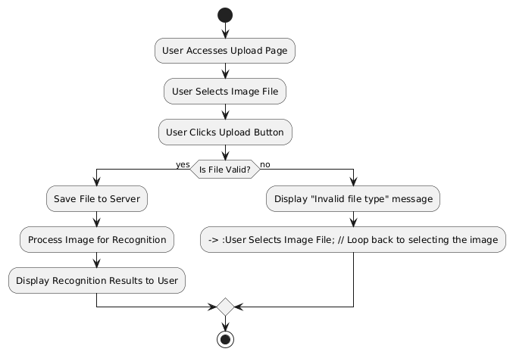
Figure 1: Flowchart for users

Use Case Diagram
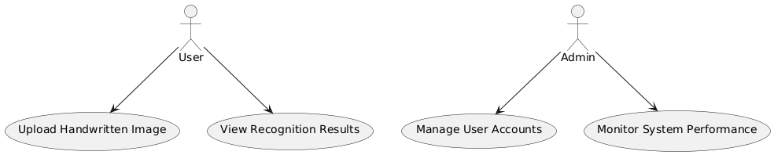

Figure 2 : Use case diagram for users


Figure 3 : Use case diagram for Admin

Description of algorithms
The system will use Convolutional Neural Networks (CNNs) as a fundamental algorithm for image processing and recognition tasks. CNNs are designed to automatically and adaptively learn spatial hierarchies of features from images, making them highly effective in tasks such as image classification, object detection, and segmentation.

Convolutional Neural Networks (CNN)
CNNs utilize layers of convolutional filters to capture patterns from the input images. These filters are trained to detect various features such as edges, textures, and shapes at different levels of abstraction. The architecture typically includes convolutional layers, activation functions, pooling layers, and fully connected layers.

Working of Convolutional Neural Networks
Step 1: Start
The process begins with input image data.
Step 2: Convolution Layer
Apply convolutional filters to the input image to extract relevant features.
Step 3: Activation Function
Use an activation function, typically ReLU (Rectified Linear Unit), to introduce non-linearity into the model.
Step 4: Pooling Layer
Implement pooling to down-sample the feature maps, reducing dimensionality while retaining essential information.
Step 5: Flatten Layer
Convert the pooled feature maps into a one-dimensional array to prepare for the fully connected layers.
Step 6: Fully Connected Layer
Connect neurons from the flattened layer to the output layer, allowing for complex decision-making based on the learned features.
Step 7: Output Layer
Generate predictions based on the processed data, which may be class labels or continuous values, depending on the task.
Step 8: Stop
The process concludes after generating the final predictions.

Gantt chart

Process | No. of Weeks
 | 1 | 2 | 3 | 4 | 5 | 6 | 7 | 8 | 9 | 10
Requirement Gathering
Planning
Designing
Coding
Testing and debugging
Implementation

Table 1: Gantt chart for Aksar (अक्षर)

Expected outcome
The system is expected to provide an efficient and accurate platform for recognizing handwritten Nepali characters. Users should be able to upload images of handwritten characters, and the system will return the corresponding digital text with high accuracy. This will facilitate the digitization of handwritten Nepali documents and help in various applications such as educational tools, digital archiving, and processing handwritten forms. The platform is also expected to be user-friendly, allowing smooth interaction with minimal technical expertise.

References

[1] | [1] H. Singh and M. Sharma, "Handwritten Devanagari Character Recognition using Convolutional Neural Networks," International Journal of Engineering Research & Technology (IJERT), vol. 8, no. 10, 2019.
[2] | [2] A. Sharma, R. K. Singhal, and P. Joshi, "A Review on Handwritten Character Recognition Techniques in the Context of Devanagari Script," International Journal of Computer Applications, vol. 176, no. 4, 2020.
[3] | [3] S. Ghosh and B. B. Chaudhuri, "Script Recognition – A Review," IEEE Transactions on Pattern Analysis and Machine Intelligence, vol. 36, no. 6, 2014.
[4] | [4] A. Gupta, "Deep Learning Approaches for Handwritten Character Recognition: A Comparative Study," Journal of Computer Science, vol. 12, no. 3, 2021.

